**SOCIAL MEDIA ANALYTICS FOR BUSINESS**

**Table of Contents**

Abstract 3

Motivation for the project 3

Design and discussion 6

Conclusion 9

Reference List 11

# Abstract

A development direction of the organization that sets its goal, task, and strategic objectives can be formulated in the first phase. These will normally be created using the history of the brand. The experience of a company is useful in a case study as it allows explaining the complexity of the options for the case study. The next move is to consider the company its staff, its values, and its community in general. This can be achieved by the past of the brand (de Zambotti, Goldstone, Claudatos, Colrain, and Baker, 2018). It may also be achieved with anecdotal cases of managers or workers, who are normally described in an HBR case study, to provide a true impression of the circumstance to the reader. Finally, a schedule must be developed for the problems and activities. Organizing incidents in a sequence helps it to forecast the next several events. It also encourages us to create solutions for the case study. The timetable frequently allows one to recognize the organization's ongoing issues.

Fitbit also provides a higher-cost premium level with customized fitness instruction. People will collaborate on their own with a wellness specialist for $54.99 a month to help people create an action plan for exercise and a health trip. people can talk straight to their coach and get customized information, along with all the other benefits that come with a Fitbit Premium standard membership. According to Feehan, Geldman, Sayre, Park, Ezzat, Yoo, Hamilton, and Li (2018), in stark comparison, Garmin in its Connect app provides preparation schedules... free of charge! Garmin Coach Schedules enable people to set an operational objective to accomplish that over several months. In reality, my first half marathon last summer has been aided by these plans. It realize that proposals for Fitbit Premium might have been more general but it still shocked me that it was just so simple.

# Motivation for the project

The case study does not conclude by simply advising on the topics involved. One may also explain the implementation of these guidelines. This is shown by a correct structure for execution. As per the viewpoint of Benedetto, Caldato, Bazzan, Greenwood, Pensabene, and Actis (2018), a comprehensive application structure allows differentiating between a normal and an over-average case study response. It also defines the modifications and assumptions that have to be made. More than one solution to the case study is necessary. This alternative would be introduced where a shift of conditions was not or could not be found in the initially suggested remedy. The alternative approach for Fitbit is described as the initial plan with a corporate plan, a corporate level strategy, and others. The case study should not just provide advice on the problems involved. One could also explain how these guidelines will be applied. This is shown by a correct structure for execution (Haghayegh, Khoshnevis Smolensky, Diller, and Castriotta, 2019). A comprehensive structure for implementation helps differentiate between an average and an over-average case study response. It also sets out the modifications and assumptions that need to be included in the method. For example, the launch of Fitbit in the US in 2006 serves as a shining example of this concept. From the beginning, the corporation has benefited greatly from customers' adaptability and concurrence.

After the rise of health-consciousness, the industry has begun to embrace new lifestyles in an accelerating manner, allowing Fitbit to capitalization to take full advantage of it. Fitbit reduced the total US market share by 25 percent but retained a significant market share in the span of the market. As commented by Hartman, Nelson, and Weiner (2018), the pursuit of the differentiating and premium business approach in the industry is Apple Watch Since the range of the Xiaomi mi-band products are in that region, they have to work to retain the offerings for the long haul and look for future opportunities in the price level of the low end. The company followed the differentiate- and lowercase or fecality approach that has recently taken root in the marketplace; it placed its concentration on ensuring ease and comfort for consumers, thus alleviating maintenance for the lifestyle they want Due to this improvement in adaptability. The Fitbit used the understructure of the business to improve the applicability to many IOS and Windows phones. Being free to expand in the industry gave Fitbit a massive opportunity to increase its market share and attention (Bai, Hibbing, Mantis, and Welk, 2018). The chances of Fitbit potentially leaning on Google to have their applications, in the Smartphone Market is high but the huge market demand on the developers pushes the users to choose it as a tool for the general Lifestyle and health tracking grounds the application into Google Play.

**Evaluation of customer review through Twitter API**

An API has several features, which include abstraction, one of which is that it allows it to integrate systems. An API decouples the program from the underlying infrastructure However long as the characteristics of the service delivery stay the same, the changes to the APIs do not affect the software on the ends. There is also a wide range of freedom in terms of facilities provided to the service provider because of this. Other things are of a similar kind, for example, if the hardware behind the API is at a data center, it is easy to migrate to virtual servers that sit in the cloud. Card Service providers should switch their cloud applications (such as credit applications) to Node.js (server-based JavaScript in Windows Azure). Much as simple plug-and-and-and-play applications have the potential to be rapidly modified to meet the needs of different industries, it is the essential concept of API-led networking that powers the digital business. Point-to-to-point connections no longer are the norm, and the time and energy are required to set up are no longer a problem.

Bai, Hibbing, Mantis, and Welk (2018), many APIs have various forms. Another way of putting it is: An example is APIs and interfaces in classes, which enable objects to communicate with each other in the Java language. Where data representation (REST). Programmable Web says there are over 15,000 freely accessible APIs and several more that businesses are using to enhance their own and external capabilities. During the Spec-Dry development phase, it will spot glitches and discrepancies just before the APIs begin to falter. In general, this will increase the production time by two weeks, but it is worth the wait. Planning API specifications upfront will save it months and even years of difficulty in building or even design when it develops an API late in a bad design (Ringeval, Wagner, Denford, Paré and Kitsiou, 2020). APIs use three principles: Resource-oriented, Safe, and Transparent. The principle is that they should be resource-oriented and secure. It would want to prepare in advance. Not only for this iteration but also in advance for possible iterations a year or two down the line. This is where REST does particularly well because it enables clients to exchange hypermedia styles, modifies, and makes them adaptive in response format. In no time at all, we are well on the way to achievement with REST. It is always necessary to have the right attitude going in the API its emphasis should be on the long term. Spec-driven architecture has an iterative implementation in mind from the start. The tests can be used to create RESTful APIs (such while mocks) as they build out the template (Reid, Insogna, Carver, Comptour, Bewski, Sciortino, and Andersen, 2017).

**Limitations of Customer Reviews**

There is a lot of phony feedback on the Internet. Several dishonest companies create bogus identities to boost their ranks and exposure. Besides, the business may be negatively discussed in the news media. People who are unaware of this distinction are deceived by negative and positive feedback. Managing the online identity is another excuse to do social listening. Additionally, it should look at the competitors’ testimonials and see if any of them are fraudulent. Finally, polls. Convenience sampling methods may not always represent the consumer's true feelings when consumers are required to complete a survey instead of deciding to write a comment, this may happen (Chu, Ng, Paknezhad, Gauterin, Koh, Brown and Müller-Riemenschneider, 2017). When it asks customers many questions, it also gets biased views regarding the goods, labels, or services. The customer is motivated to have honest input for this kind of data collection Customers should give what the company wants to hear rather than what the company tells them they need to hear. These users will be motivated to fill out the survey arbitrarily, as long as there is a prize on the line. Considering consumer input is important when doing market research. It must seek out more and more diverse and multiple data to find reliable results.

**Social listening**

People are not necessarily willing to voice their opinion regarding a company's goods in the channels the brand owns, though. Since there are so many outlets, executives cannot read any of them. Social listening is when it comes to the way. 'Social platforms monitor keywords to gather all online references for products and brands' This outlet will combine user feedback from national, local, and internet media and several online channels to provide a full picture of their content. As commented by Imboden, Nelson, Kaminsky, and Montoye (2018), often, Social Listening collects the data and compiles analytics that includes information about all ratings, such as click-through rates, reach, likes, and favorites. As it can see below, it can make a side-by-side comparison with constructive and negative comments. Categories would be assigned depending on the results of the survey. When we take the analogy of a business that produces baby goods, the best way to describe its approach is: In this case, let us say it monitors its customers' ratings Based on each review's sentiment; they will be categorized by the price, consistency, and effectiveness and texture. The company will use this subject as a strategic decision-making resource. In addition, it identifies the product's strengths and disadvantages for branding (Liang and Chapa-Martell, 2019). It should still keep track of the competitor's conversations and learn about how they are performing with the consumers and what they have to say about their brand. So that the staff knows what they are doing, it may evaluate their work using social listening apps, it will be able to track and react to all the various kinds of consumer feedback.

# Design and discussion

To make business analytics for Fitbit sense, a huge amount of data is required to do that. This research is intended to do business analytics that requires data from diverse sources by overriding data generated using Twitter. To conduct this research, Twitter API is being used for this research. An API is referred to as application software that is capable of analyzing data found from various social media sources i.e. Twitter, Facebook, or Instagram. Not only these social networking sites are used to conduct this analysis, but also various live websites are being used to generate data from different users. For a better understanding of the APIs, it is working as a trader between the users. API’s consists of various kinds of coding, which is then accumulated to get the desired analysis outcome. As an example, when we order something from a website, we did not get that product directly from the warehouse. We have to be dependent on the delivery boy to get our product from the warehouse. Here that delivery boy is occupied as a trader or an API.

* **Data harvesting from Twitter**

REST system or we can say Representational State System is the ultimate procedure by which is need to toil the API swiftly. This REST system is responsible for reading & writing the datasets provided by the user. Twitter API is constructed using 4 partitions such as Tweets segment, user, entities & location unit. HTTP servers are needed to run these APIs swiftly. Data need to be extracted using different procedures from Twitter.

Beneath the home section, there is accessibility by which one can get the reviews of last month. In that section, the user can get all the data related to the activities such as the number of visitors increased or decreased, how many tweets have been posted in the last month, total numbers of posts that have been posted including all of the hashtags. Additionally, one can also check either the number of followers has been increased or not. (Vyshnavi, Venkata Raju, Vamsi Krishna and Bhavya Shree, 2017)

To access multiple user data from different sources, Twitter APIs play a vital role. It is capable of creating communication between multiple users. Additionally, creating a post using hashtags, creating brandings, repeating history search, different keywords can be accessed through streaming APIs. These types of API can be accessed through ‘Tweepy', a python library that is very much user friendly.

* **Dataset construction**

Datasets found from different sources are generally unprocessed data that needs to be counteracted properly. Without proper counteraction, these datasets cannot be used for data analysis. Providing data into different algorithms needs offset & scrapped data. To generate the most accurate results, any kind of emoji, blank spaces, or special characters need to be removed properly otherwise it can generate multiple issues while analyzing. If any message or any post consists of 3 characters or less than that, it can be firmly added for analysis.

These processed data are then taken to the Google sheets, where these data are formatted properly for access. Usually, these files are having .csv file extension which contains different data from different sources, such as Emails different message sources.

lastly, cleaning up of these data need to be done so that there will be no such extra codes or any garbage remains. If this garbage remains, then it will be a tough job to process those data for analysis.

* **Data investigation found from Twitter**

After gathering the datasets from various sources, these data need to be formatted in a table format so that they can be accessible. For this specific job, the analytics department of Fitbit sense uses a special kind of spreadsheet software i.e., Google sheet or Ms-Excel. This software is easy to use & can be collected easily. Here in this spreadsheet software data need to be imported in table format. These datasets might be product pricing or product details or customer details such as the name of the customer & contact details (Power, Heavin, McDermott and Daly, 2018). These datasets are preserved in the database of the company & kept confidential to others. After that, these data sets are imported on Tableau. This is an analytics tool consists of a dashboard along with predefined templates.

* **Conjuring up of data**

Using Google analytics premium version, quick analysis can be accessed very easily. This software is very easy for anyone who doesn't know anything about it. Without having any knowledge, one can easily track those analytics. To do so, first of all, signing in to the google account is obligatory. Fitbit sense's analytics department uses this software to keep track of their customer's activities & preferences. Near about 65% of annual outflow has been shortened with the use of this data analysis procedure. Additionally, this data analysis helps to reduce total annual spending and also upsurge annual turnover. (Chatterjee et al., 2018)

Analysis of customer data & feedbacks helps to keep track of choices that have been made by the customers of Fitbit sense. Repeated adding of datasets also helps to understand what trends are going on in the market. Top selling products by Fitbit sense can also be traced without any issue. Using this analysis, Fitbit sense has put up growth in their annual turnover which is a plus point for Fitbit sense. Keeping track of customer preferences also helps to provide customer satisfaction. Along with that, the marketing department of Fitbit sense can provide advertisement campaigns of their trending & best-selling products to attract more customers to cultivate their profit amount. This can be attained through the premium version of Google analytics. Cultivation of Fitbit sense online application helps to involve more customers in their business. (Suryadi and Kim, 2019)

# Result and discussion

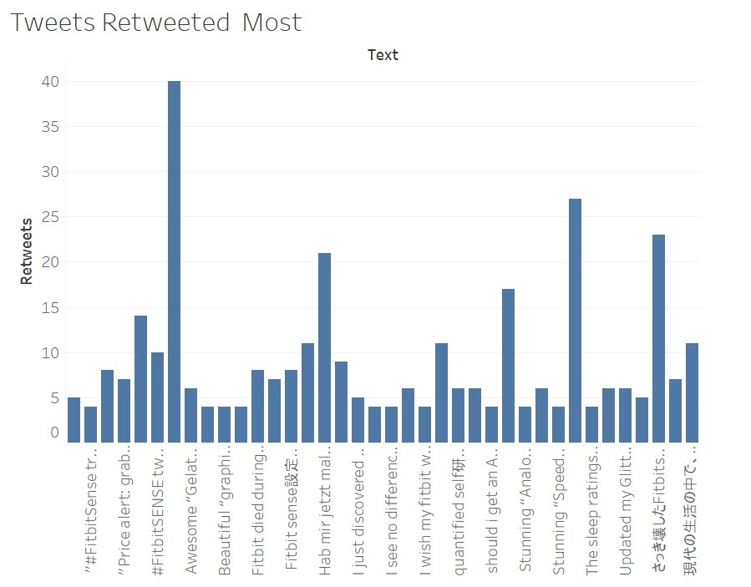

Figure 1: Retweet’s analysis

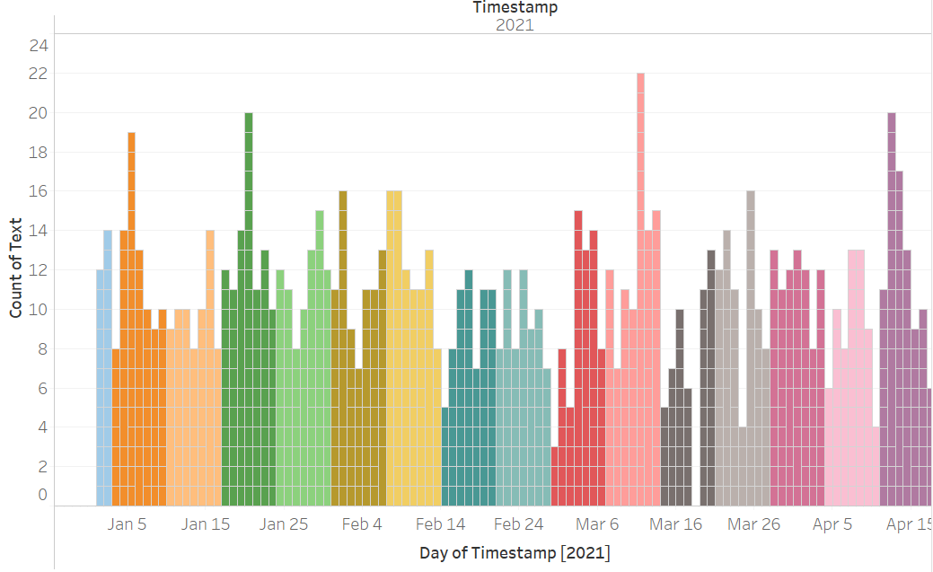

Figure 2: Frequency of tweets over months

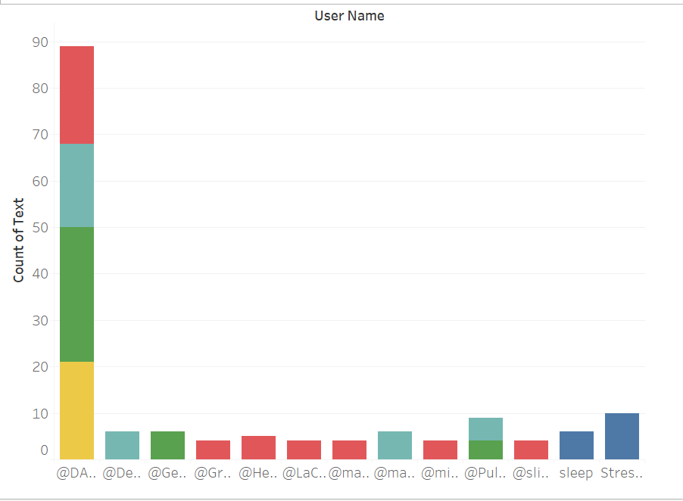

Figure 3: Tweet Frequency of some user

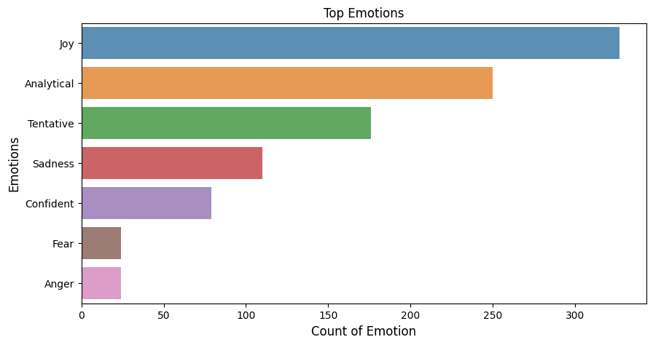

Figure 4: Sentiments in the post

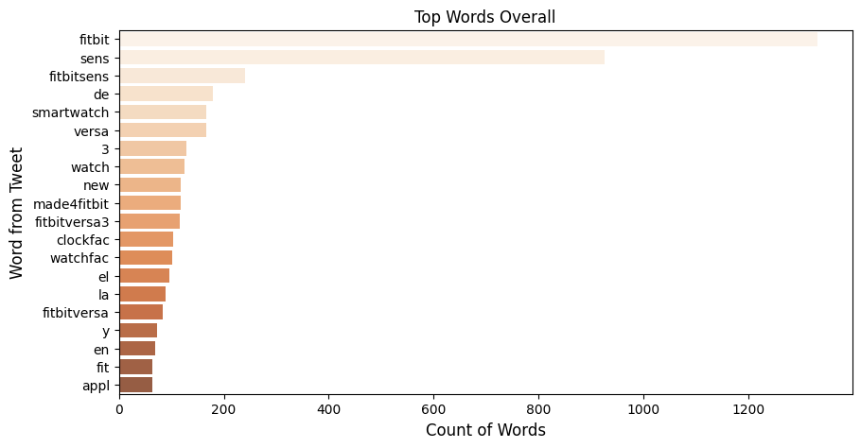

Figure 5: Overall words count

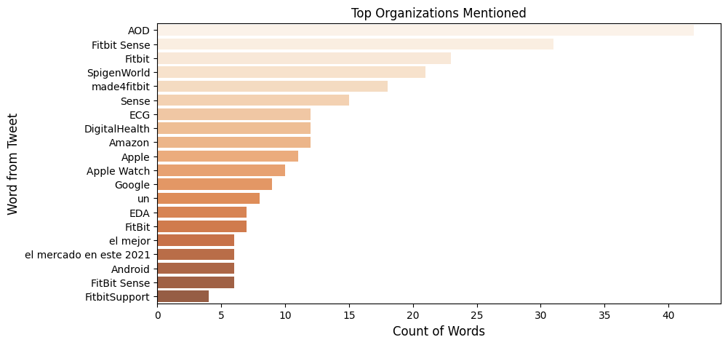

Figure 6: Top mentioned organization

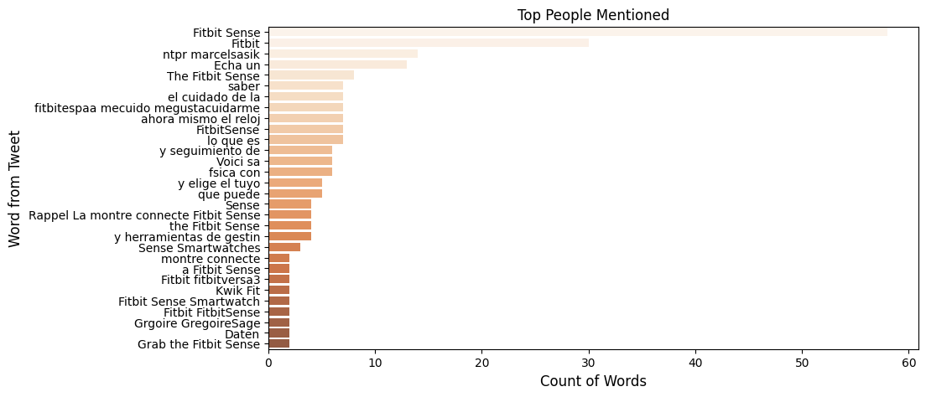

Figure 7: Top mentioned people

# Conclusion

Fitbit Premium is Fitbit's, well, premium subscription package providing Fitbit customers with extra information, advice, and practice routines. Think like every other free service it might use—everybody can free download and use the Fitbit software, but if it chooses, anything that the Fitbit community will do it would be charged a monthly charge. Fitbit products capture tones of wellness and exercise information all day long. Fitbit Premium aims to make it appreciate how the data affects different aspects of everyday life. Premium "turns the wrist statistics into customized instructions" in the words of Fitbit. Fitbit Premium has four key advantages, which are not included in the normal Fitbit applications: organized programs, videos on workouts and customized wellness and wellbeing tips, and a unique view of Health Metris.

Many analysts argue that more than one product maker needed to be Fitbit. One way for Fitbit is to extend into other sectors, such as the wellness sector. Present Fitbit devices concentrate on fitness and wellbeing and provide their customers with a trendy product. The design of their product may be extended to provide trackers for health information including glucose indicators and other tracking equipment. Fitbit should even concentrate on increasing its foreign presence. The fitness level tracker industry in the United States is declining, but a potential growth could take place on the international market. Fitbit is the world's most beautiful hardware, health, and accessories family. Fitness is different for everybody. Not all fit one size. That is why Fitbit built a product family that works seamlessly together, budget, applications, and priorities. Fitbit has been developing accessories for eight years for which everybody wants to wear and an application that everybody likes to use.

This is the only thing they are doing, so Tech Crunch, Vogue, Quick, People, Today, USA Nowadays, Wall Straight Journal and self-tell me they are very good at it. When it achieves the objectives, how it spends the day decides. Moreover, it will see what is achievable from watching the success. From 2014 to 2015, the revenues of Fitbit have more than doubled, with sales of $2.5 billion for full-year 2016, boosted by innovative innovations and growth across new regions. As their income grew, their stocks declined considerably. The challenge of the smartwatch and the declining interest in a fitness tracker is presumably attributed to this dramatic decrease. Based on this decline in the company's valuation and asset value, I will conclude that the new approach of Fitbit does not succeed, since they are not sufficiently diverse to survive in the evolving sector.

# Reference

Bai, Y., Hibbing, P., Mantis, C. and Welk, G.J., 2018. Comparative evaluation of heart rate-based monitors: Apple Watch vs Fitbit Charge HR. Journal of sports sciences, 36(15), pp.1734-1741...

Benedetto, S., Caldato, C., Bazzan, E., Greenwood, D.C., Pensabene, V. and Actis, P., 2018. Assessment of the Fitbit Charge 2 for monitoring heart rate. PloS one, 13(2), p.e0192691.

Chu, A.H., Ng, S.H., Paknezhad, M., Gauterin, A., Koh, D., Brown, M.S. and Müller-Riemenschneider, F., 2017. Comparison of wrist-worn Fitbit Flex and waist-worn ActiGraph for measuring steps in free-living adults. PLoS One, 12(2), p.e0172535.

de Zambotti, M., Goldstone, A., Claudatos, S., Colrain, I.M. and Baker, F.C., 2018. A validation study of Fitbit Charge 2™ compared with polysomnography in adults. Chronobiology International, 35(4), pp.465-476.

Feehan, L.M., Geldman, J., Sayre, E.C., Park, C., Ezzat, A.M., Yoo, J.Y., Hamilton, C.B. and Li, L.C., 2018. Accuracy of Fitbit devices: a systematic review and narrative syntheses of quantitative data. JMIR mHealth and uHealth, 6(8), p.e10527.

Haghayegh, S., Khoshnevis, S., Smolensky, M.H., Diller, K.R. and Castriotta, R.J., 2019. Accuracy of wristband Fitbit models in assessing sleep: systematic review and meta-analysis. Journal of medical Internet research, 21(11), p.e16273.

Hartman, S.J., Nelson, S.H. and Weiner, L.S., 2018. Patterns of Fitbit use and activity levels throughout a physical activity intervention: an exploratory analysis from a randomized controlled trial. JMIR mHealth and uHealth, 6(2), p.e29.

Imboden, M.T., Nelson, M.B., Kaminsky, L.A. and Montoye, A.H., 2018. Comparison of four Fitbit and Jawbone activity monitors with a research-grade ActiGraph accelerometer for estimating physical activity and energy expenditure. British journal of sports medicine, 52(13), pp.844-850.

Liang, Z. and Chapa-Martell, M.A., 2019. Accuracy of Fitbit wristbands in measuring sleep stage transitions and the effect of user-specific factors. JMIR mHealth and uHealth, 7(6), p.e13384.

Reid, R.E., Insogna, J.A., Carver, T.E., Comptoir, A.M., Bewski, N.A., Sciortino, C. and Andersen, R.E., 2017. Validity and reliability of Fitbit activity monitors compared to ActiGraph GT3X+ with female adults in a free-living environment. Journal of science and medicine in sport, 20(6), pp.578-582.

Ringeval, M., Wagner, G., Denford, J., Paré, G. and Kitsiou, S., 2020. Fitbit-based interventions for healthy lifestyle outcomes: systematic review and meta-analysis. Journal of medical Internet research, 22(10), p.e23954.

Viswanath., K. and Verma, P., 2019. The Hybrid Approach for Sentimental Analysis of Twitter Data. *International Journal of Computer Sciences and Engineering*, 7(6), pp.612-617.

Chatterjee, S., Deng, S., Liu, J., Shan, R. and Jiao, W., 2018. Classifying facts and opinions in Twitter messages: a deep learning-based approach. *Journal of Business Analytics*, 1(1), pp.29-39.

Edwards, J. and Rodriguez, E., 2019. Remedies against bias in analytics systems. *Journal of Business Analytics*, 2(1), pp.74-87.

Goyal, D. and Garg, A., 2019. Sustained business competitive advantage with data analytics. *International Journal of Business and Data Analytics*, 1(1), p.4.

Power, D., Heavin, C., McDermott, J. and Daly, M., 2018. Defining business analytics: an empirical approach. *Journal of Business Analytics*, 1(1), pp.40-53.

Rittenhouse, B., Mi, X. and Allen, C., 2019. Beginner's Guide to Twitter Data. *The Programming Historian*, (8).

Suryadi, D. and Kim, H., 2019. A Data-Driven Methodology to Construct Customer Choice Sets Using Online Data and Customer Reviews. *Journal of Mechanical Design*, 141(11).

Vyshnavi, R., Venkata Raju, K., Vamsi Krishna, G. and Bhavya Shree, Y., 2017. a survey on sentiment study in twitter data using Hadoop streaming API. *International Journal of Engineering & Technology*, 7(1.1), p.618.

# Appendix

Table public links for some plots:

<https://public.tableau.com/profile/student8310#!/vizhome/FitBitSence/Dashboard1?publish=yes>

Extracted dataset for analysis